GSK | End-User Development (EUD) Checklist

Introduction
This document supports GSK Tech to perform a high-level risk and compliance control assessment for end-user developed solutions at GSK Power Platform Environment. It will also help to determine whether a risk and compliance assessment (R&CA) is necessary. It is required to grant Data Governance Form Approval for the use of Medum and High environments available for Tech users. This document is GSK internal use only.

Instruction:
- Please answer all questions.
- Please include relevant comments, evidence, and supporting documentation to justify your responses or describe alternative approaches considered during solution development.
- Please incorporate a standard timeline of five (5) business days into your project schedule for GRC (Governance, Risk, and Compliance)’s initial review and control verification of the checklist.

High-level Process:
Description | Responsible | Applicability
- Fill in the EUD checklist and submit it for GRC review | BU Tech Owner | All types of development
- Review of the input by Tech Owner to the EUD checklist | GRC | All types of development
- Confirmation of the EUD checklist approval and verification of document storage  Veeva Quality Docs (VQD) is recommended as a repository. | BU Tech Owner | All types of development
- Submission of Data Governance Form Approval Request with reference to the approved EUD checklist (e.g., your checklist’s VQD ID in the comment section) | BU Tech Owner | Not Applicable for Power BI
- For changes to the existing application, utilize the approved checklist to add/remove contents and send for review/approval.

Business and Technical scope of the EUD solution

Business Area: | ☐ Commercial  ☐ Global Functions  ☐ Global Health  ☒ Global Supply Chain  ☐ Research & Development  ☐ ViiV Healthcare  ☐ Other ( )
BU Tech Area: | ☐ Commercial Digital & Tech  ☐ Digital Platforms & Technology Foundations  ☒ Enterprise AI  ☐ Global Supply Chain Digital & Tech  ☐ Research & Development Digital & Tech  ☐ Other ( )
Solution Name:  Enter the name of the solution. | My Meetings Twin Agent
Solution Version:  (e.g. 1.0.0.7 (deployed build) if applicable, can be empty) | 1.0.0.7 (deployed build)
Solution description:  Enter the brief description explaining the business process, the solution addresses and how end users are expected to use it. | My Meetings Twin Agent is a Microsoft Copilot Studio-based conversational solution that supports governance meeting preparation, KPI tracking, and DIA (Decision / Input / Awareness) data collection.  The solution enables users to:  - Configure meetings and KPI tracking preferences  - Assign KPI ownership and trigger notifications  - Capture and validate DIA inputs for governance meetings  - Monitor completion status of meeting preparation tasks  - Identify risks such as missing inputs or red KPIs  The agent integrates with Microsoft Dataverse, Office 365 Outlook, Office 365 Users, Office 365 Groups, Planner, Microsoft Teams, Azure AD, SharePoint Online, Power BI, and Planner to orchestrate meeting workflows and support structured pre-read preparation.
BU Tech Owner and GSK email address:  (This section needs to have a name of Tech person. Place N/A if not designated) | Vinciane Polet [vinciane.x.polet@gsk.com]
Business Owner and GSK email address: | Sumit Kaura [sumit.x.kaura@gsk.com]
Checklist completed by:  Name of the Tech person (or other appropriate person) who filled in this document | Ana Ocariz
Checklist reviewed by:  Name of the GRC who filled in this document | Yves Franquinet

Solution description
Brief commentaries are expected for any responses.
# | Scope |  | Comments and Supporting Evidence
1. | Which end user development tools are being developed?  If other, please explain in the Comments section. | ☐ App  ☒ Automate  ☐ BI  ☒ Copilot Studio  ☐ Other ( ) | Please specify in case of selecting “Other” option:
2. | Information Classification:  For further details, please refer Data Classification at GSK: | ☐ Public  ☐ Proprietary  ☒ Confidential  ☐ CSI | Indicate attributes in comments:  The solution processes:  - KPI data  - Meeting configuration  - Operational governance data  Data is classified as Confidential due to internal business sensitivity.
3. | Personal Information Classification:  For definition of categories, please refer Privacy page: | ☐ None  ☒ Basic  ☐ Restricted  ☐ Sensitive | Indicate attributes in comments:  Includes:  - User names  - Email addresses  - Meeting participants  No sensitive personal data is processed.
3a. | If restricted or sensitive PI is handled, Privacy Inventory or Impact Assessment may be needed. Please reach out to your Privacy contact (also see Privacy Standard) |  | Please attach copy of Privacy Inventory record (where required):  No restricted or sensitive personal data processed. Privacy impact is low. No Privacy Inventory required.
4. | Who is (are) the data owner(s) for the solution?  Please provide evidence for the approval from the data owner for the use of the data to your solution. |  | Please describe:  Data owners include:  - KPI dataset owners (Power BI)  - Meeting governance stakeholders  - Business process owners  Data usage aligns with existing governance processes and authorised access controls.
5. | Does the solution support a pharmaceutical industry regulated business process (e.g. GxP) or the integrity of records/data in a GxP system? | ☐ Yes  ☒ No
6. | Does the solution support a Sarbanes-Oxley regulated business process?  Please contact the SOX team when your answer is Yes. | ☐ Yes  ☒ No
7. | Does the solution support a critical business process with a Recovery Time Objective of 14 days or less? | ☐ Yes  ☒ No
8. | Country (Market) of Use (The country/market where the users of app reside) and Scope of Use (E.g., BU/Sites, number of users,)  See also High-Risk Jurisdictions (HRJs) and Restricted Markets |  | - Global usage across GSK users  - Primarily internal (Global Supply Chain / enterprise users)  - Number of users: scalable, multi-user environment  No restricted markets targeted.
9. | Does the solution have AI functionality?  In case of Copilot Studio development, having AI Accountability Report is a mandatory requirement. | ☒ Yes  ☐ No | Please attach a copy of approved AI accountability report:

Architecture and dataflow
Brief commentaries are expected for any responses.
# | Scope | Yes / No | Comments and Supporting Evidence
1. | General architecture and dataflow |  | The solution is built using:  - Copilot Studio (conversation orchestration)  - Power Automate flows (backend processing)  - Dataverse (configuration storage)  - Power BI (KPI datasets)  - Microsoft Graph (user & meeting data)
1.1. | Please provide Architecture and/or end-to-end Data-Flow Diagram for information purposes. | - | (Utilize Section 8.)
1.2. | Does the application have connections with other GSK systems? (e.g., via Connectors, Dataverse, API) | ☒ Yes  ☐ No | List and describe the system and connection method:  - Microsoft Graph (user and meeting data)  - Dataverse (configuration and storage)  - Power BI (KPI retrieval)  - Planner (task creation)
1.3. | Does the application have connections with other non-GSK external systems? (e.g., via API) | ☐ Yes  ☒ No | List and describe the system and connection method:
2. | Data inputs & ingestion
2.1 | Will any data be extracted from or ingested into other systems (e.g., GSK Azure, SAP, Workday, or SaaS)? | ☒ Yes  ☐ No
2.2 | Please explain how data is being transformed and extracted from or ingested into your solution.  Note: Describe any use of data gateways and/or connectors being used for the gathering and loading of data into the solution. |  | - Data retrieved from Power BI datasets  - User configuration stored in Dataverse  - Meeting data retrieved via Graph API
2.3 | Is there any data being collected directly from end-users?  Please describe the purpose and characteristics of the end-users. | ☒ Yes  ☐ No | Users input:  - DIA data  - KPI updates  - Meeting configuration  Used only for meeting preparation workflows.

Access management and data protection
Brief commentaries are expected for any responses.
# | Scope | Yes / No | Comments and Supporting Evidence
1. | Identity & access management
1.1. | Does your EUD solution authenticate users through GSK Tech Access Management solution (e.g., GSK AIR/SSO)? | ☒ Yes  ☐ No | Please describe:  Users authenticated via Microsoft Entra ID (SSO).
1.2. | Is the solution accessed by users outside of GSK (e.g., account without GSK AIR/SSO (MUD-ID))? | ☐ Yes  ☒ No | Please describe:
1.3. | What are roles and privileges in your solution? |  | (For example, user/developer/functional account)  - End User (organiser / attendee)  - Administrator  - Service-level access via Copilot platform
1.4. | Who is responsible for granting/removing access and for periodic access review?
2. | Data Protection
2.1. | Are custom or additional encryption methods applied (digital signatures, hashing)? | ☐ Yes  ☒ No | No custom encryption implemented; relies on Microsoft 365 native controls.

Environment & connector used
Brief commentaries are expected for any responses.
Scope | Comments and Supporting Evidence
Which GSK Power Platform environment is used?  - Ultra-Low  - Low  - Medium  - High (RPI/SPI/CSI/GxP/SOX/Custom connectors/Copilot Studio)  - CopilotStudio_PP_High_Shared_POC | (For example, Global Support Function Medium Dev)  High  A specific new environment was developed: Copilot_Studio_GSC_Dedicated_DEV
List of connectors used  (List connectors + rationale) | - Microsoft Graph → user & meeting data  - Dataverse → configuration storage  - Power BI → KPI data retrieval  - Planner → task creation

Solution components inventory
Brief commentaries are expected for any responses.
Scope | Comments and Supporting Evidence including
Automations  List Power Automate flows  (Also describe name and purpose) | List and describe:  - AF_PreSetupConfig  - AF_SendEmail  - Append HTML Slides  - Complete DIA Status for Meeting Event  - Complete Meeting Event  - Complete Planner Task by Id  - Create Calendar Meeting  - Create DIA Planner Task  - Create Planner Tasks in Dataverse  - Create Post Meeting Tasks  - DIA Notification to Task Owners and Attendees  - Find Meeting in Dataverse  - Find User Names by Emails  - Get Basic User Data  - Get Calendar Event by Meeting Event ID  - Get Event Ongoing Tasks  - Get KPI Data Points  - Get KPI Data Values  - Get Last Meeting Event Occurence  - Get Lower Tier KPI DIA Data  - Get Meeting AI Insights  - Get Meeting Configuration by Event Id  - Get Meeting Event by Id  - Get Meeting Event Deck  - Get Meeting Events  - Get Meeting Recording Transcript  - Get Planner OverdueTasks  - Get Submitted DIA Data for HTML Slide  - Get Submitted DIAs Data  - Get Team Sharepoint Site Url  - Get Tier Level Hierarchy  - Get User Assigned DIAs  - Get User Events With Active DIAs  - Get User Meeting Configurations  - Get User Meeting Configurations V2  - Get User Name - Email  - Get User Teams Recurring Meetings  - GetEmails  - GetPlannerByGroupID  - Handle Meeting Event Attendees  - Handle Updated Post-Meeting Tasks  - New Get KPIs Data  - PA_AddNewMeetingEvnt  - PA_EventWorkingDay  - PA_OnNewSetupCreation  - PA_SendDIANotificationToOrganizer  - PowerBI - Get KPIs List  - PowerBI - Get MS Projects List  - Send Email  - Update Calendar Event Attendees  - Update Calendar Meeting Event  - Update DIA Task Data  - Update Meeting Event Attendees in Dataverse
Dashboards / Reports  List dashboards | No standalone dashboards. KPI data retrieved from Power BI.
Other Components  Other new entities (e.g., data storage, files, supporting assets) | - Copilot Studio topics  - Dataverse tables  - Configuration JSON structures

Architecture and dataflow diagram
(Attach your diagram for informational purpose; describe data origins/destinations and technical boundaries (e.g., segments, APIs, integrations, and ownership).

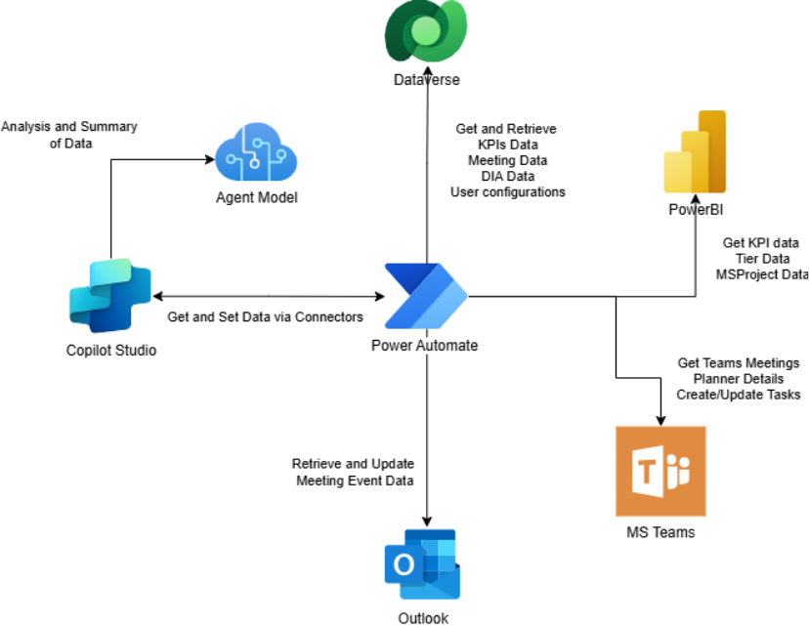

References:
Identifier | Title
RAI-Meeting-Agent | AI Accountability Report – My Meetings Twin Agent
TDD-Meeting-Agent | Technical Design Document – My Meetings Twin Agent

Document version:
Version | Description

Checklist template version:
Version

